**Project Design Phase-II**

**Technology Stack (Architecture & Stack)**

|  |  |
| --- | --- |
| Date | 03 October 2022 |
| Team ID | PNT2022TMID19246 |
| Project Name | Emerging methods for early detection of forest fire |
| Maximum Marks | 4 Marks |

**Technical Architecture:**

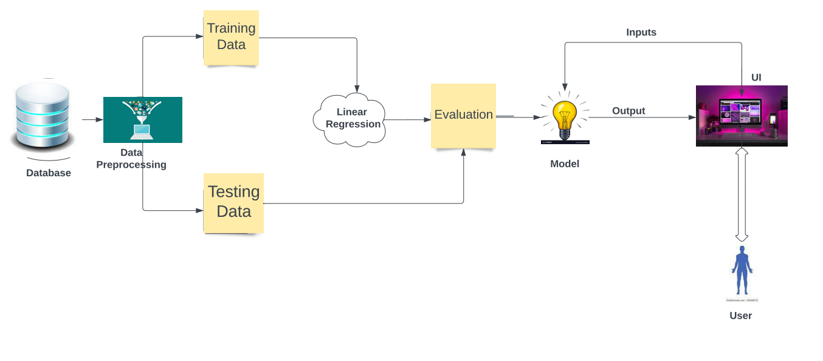

**Table-1 : Components & Technologies:**

|  |  |  |  |
| --- | --- | --- | --- |
| **S.No** | **Component** | **Description** | **Technology** |
|  | User Interface | How user interacts with application | HTML, CSS, Python |
|  | Fire predection | Here the fire in forest is predicted | Keras,CNN |
|  | Forest fire predecting resourse reccommendation | The forest fire predecting resource is recommended | User interfaces,HTML,CSS |
|  | Dataset | The training and testing data are collectively stored | Kaggle.com,data.gov,UCI machine learning repository |
|  | File storage | File storage requirements | MySQL, NoSQL, etc. |
|  | Cloud Database | Database Service on Cloud | IBM ,local file system |
|  | File Storage | File storage requirements | Image recognition modules |
|  | Modules | Purpose of deep learning | IBM Weather API, etc. |
|  | Infrastructure(Server) | Application development on local system-local server configuration | Local file system |

**Table-2: Application Characteristics:**

| **S.No** | **Characteristics** | **Description** | **Technology** |
| --- | --- | --- | --- |
|  | Open-Source Frameworks | List the open-source frameworks used | Open source-PyCharm anaconda navigator,flask framework |
|  | Login | List all the security implemented | Security-OWASP |
|  | Scalable Architecture | Justify the scalability of architecture | PyCharm |
|  | Availability | Justify the availability of application | Web appliaction access to all |
|  | Performance | Design consideration for the performance of the application | Convolution Neural Networks |